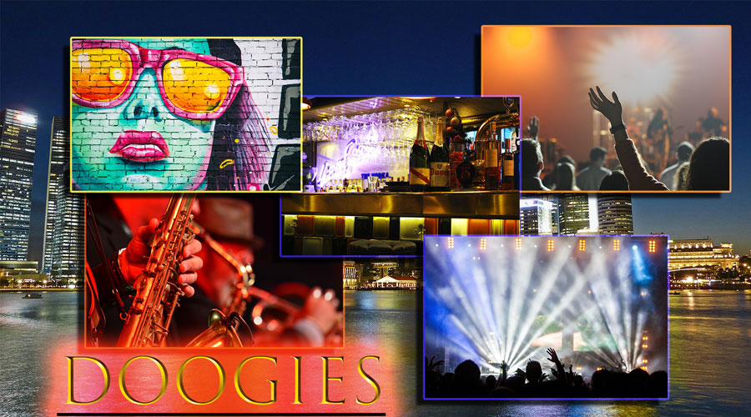

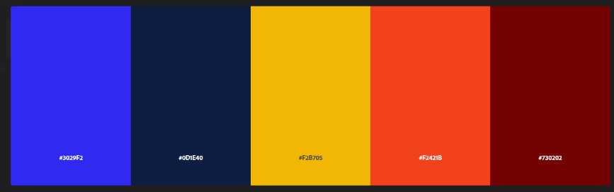

Doogies basic color pallet

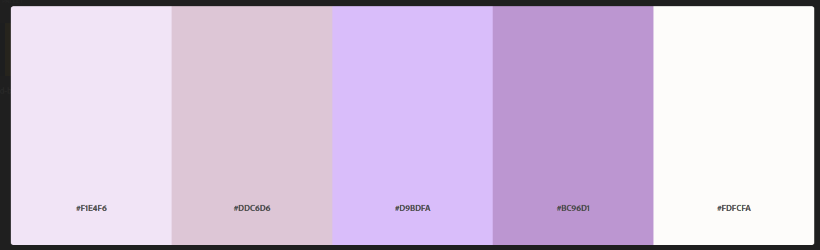

Doogies monochromatic color pallet

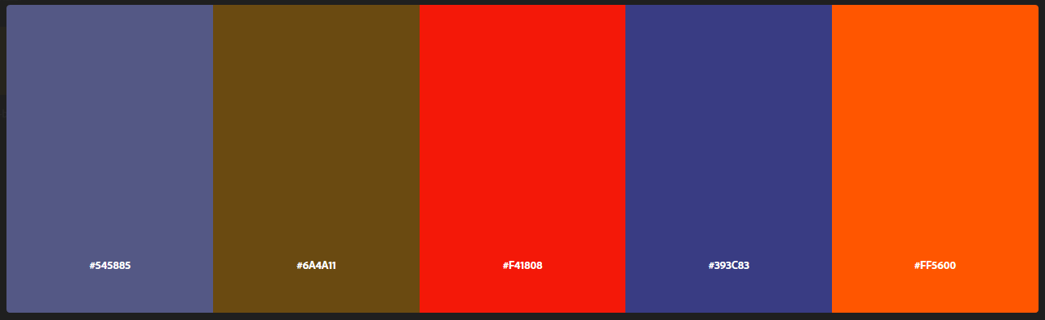

Doogies anologic color pallet

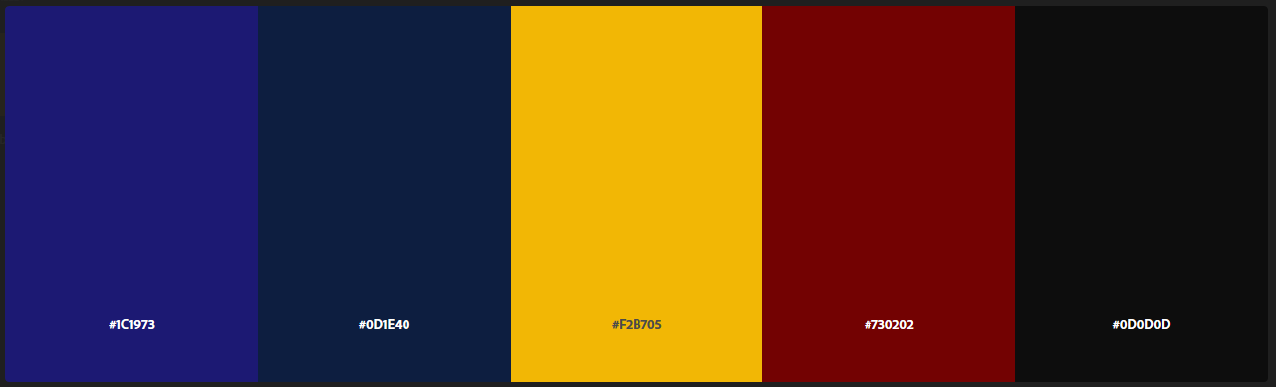

Doogies Dark color pallet

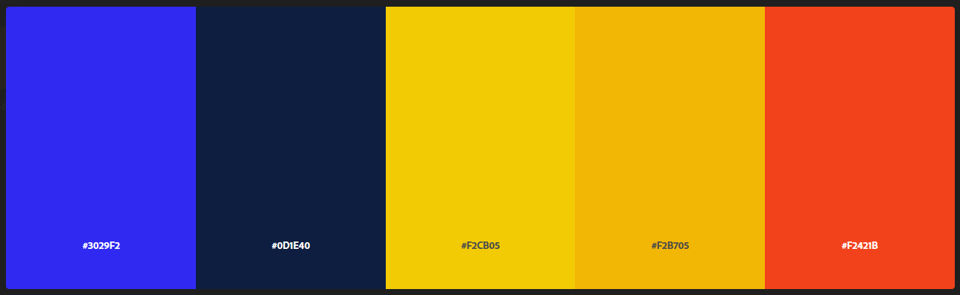

Doogies bright color pallet

This is the pallet that I have chosen for Doogies. When I think about Doogies party venue’s I think about vibrant colors full of energy with a dark background to make them stand out. Just like a nightclub with bright colorful lights yet somehow its still dark.

Why did I pick these colors?

* #3029f2- BlueBonnet- instills confidence. A “Go Get Em’” attitude.
* #0d1e40- Maastricht blue- Deep and impactful Delivers the full experience with no cut corners.
* #f2cb05- Yellow (Munsell)- Grabs peoples attention.
* #f2b705- Selective yellow- uplifting and illuminating. Conveys youthful energy.
* #f2421b- Orioles orange- conveys excitement and enthusiasm as well as being a very social color.

For Doogies I want to instill into people a fun and memorable experience that no matter what their party needs are, Doogies will deliver the full experience and give you confidence and assure you that your party, no matter what it is, will be a smash hit.